# Basic Series Parallel Components

Written by Mark Webster, Connor Sheehan, Ousema Zayati

Learn to calculate values of resistors, capacitor, and inductor in parallel and in series.

Last update: 3/20/2019

## Preliminaries

### Ohms Law

For almost all circuits, the principle called Ohm’s law applies. This is a simple linear relationship between voltage, current, and resistance. In AC circuits the terms are vectors, usually in polar form, for example R becomes Impedance (Z) which is a function of frequency.

$V = I*R$

V is voltage measured in volts, I is current measured in amps, R is resistance measured in ohms.

Note: the units for V,I,and R are important. They must be volts, amps, and ohms. Conversion is often needed.

K means multiply by 1000. For example, 1.8K ohms = 1.8*1000 =1800 ohms.

M means multiply by 1000000. For example, 1M ohms = 1*1000000 = 1,000,000 ohms.

mA means milliamps. Divide by 1000 to get amps. For example, 15mA = 15/1000 = 0.015 amps

$μA$ means microamps. Divide by 1,000,000 to get amps. For example 120 micro-amps is 120/1000000 = 0.000012 amps

V = IR is the form of ohm's law when current (I) and resistance (R) is known and voltage must be calculated. The equation can be re-arranged when the current or resistance is unknown.

$R = \frac{V}{I}$ when voltage and current are known but resistance is unknown.

$I = \frac{V}{R}$ when voltage and resistance are known but current is unknown.

***Question 1:***

If an LED has a maximum current of 15 milliamps, and the voltage is 3.3 volts, what is the limiting resistor value?

***Exercise 1:***

Measure the voltage on a battery. Measure the resistance of a resistor.

Put a battery, resistor and meter in series. Measure the current. Verify with ohms law.

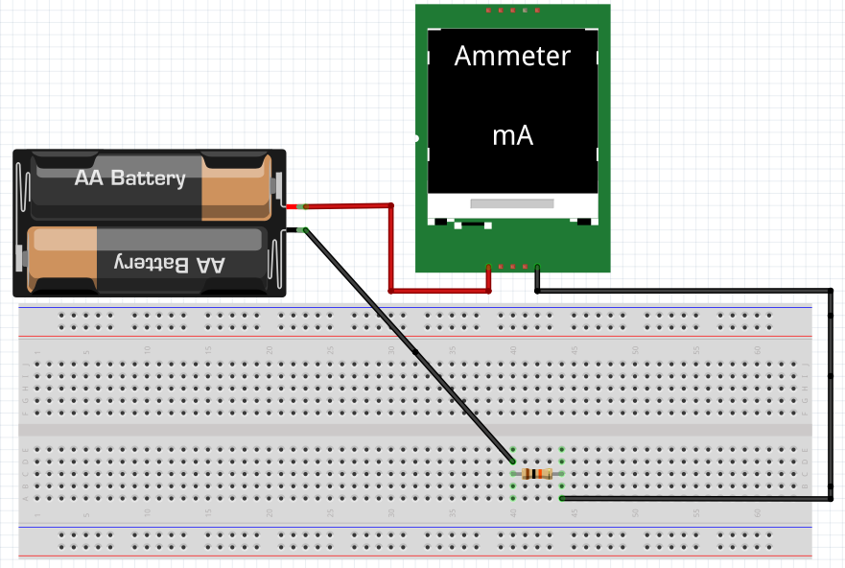

### Series and Parallel

Electronic components electrically connected “head to tail” in a row or in series, is called in series.

The current I is the same through all the components.

I = I1 = I2 + I3 …

The total voltage in a series circuit is the sum of the voltages across each component.

V = V1 + V2 + V3 +...

Parallel components are have all their “heads” and all their “tails” connected.

<https://en.wikipedia.org/wiki/Series_and_parallel_circuits>

(Note: most images are courtesy of Wikipedia)

#### Inline Question: Draw a diagram of two items in series, and in parallel

## 

## 

## 

## Batteries

With batteries in series, the voltages add, but the current stays the same. V = V1 + V2+...

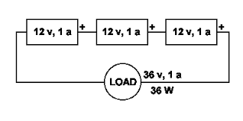(Note: replace this image)

For batteries of the same voltage in parallel, the voltage stays the same but the current adds.

I = I1 + I2 + I3…

When batteries have different voltages it is difficult to calculate because the higher voltage battery may end up charging the lower voltage battery. Generally it is not recommended to connect different batteries in parallel.

#### Inline Task: Show battery holder with batteries in series

## Resistors

Resistors add in series and in parallel sum by reciprocal equation.

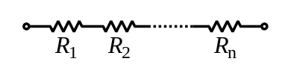

Series R = R1 + R2

Parallel

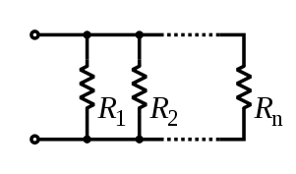



#### Inline Task: Put two resistors on a breadboard in series, in parallel

#### Inline Task: Put a 1K and a 10K resistor in parallel on a breadboard.

Calculate and then measure the resistance.

## Capacitors

Add by reciprocal equation for series, add when in parallel ( C = C1 + C2 + … )

Series capacitors:

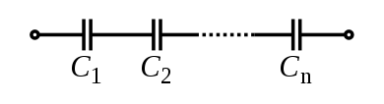



The units must be the same when calculating with several capacitors. The basic unit of measurement for capacitance is a farad (F). This is a very large unit so typically capacitors are rated in microfarad (𝜇F which is $10{}^{-6}$ farads), nanofarad (nF which is $10{}^{-9}$ farads) and picofarad (pF which is $10{}^{-12}$ farads). To convert from 𝜇F to nF multiply 𝜇F by 1000. To convert pF to nF divide by 1000. To convert nF to pF, multiply by 1000. To convert 𝜇F to pF, multiply by 1,000,000.

## Inductors

Inductors work like resistors. In series, add the inductance. Parallel inductors form a total found by the reciprocal equation.

Series:

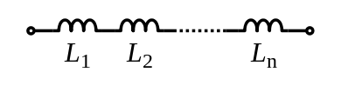

L = L1 + L2 + L3 + … + Ln

Parallel

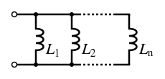

The units must be the same when doing these calculations. Inductors are typically rated in millihenries (mH which is $10{}^{-3}$ henries), microHenries (𝜇H which is $10{}^{-9}$ henries) To convert from 𝜇H to mH multiply 𝜇H by 1000. To convert 𝜇H to mH divide by 1000.

#### 

#### 

#### 

#### 

#### 

#### 

#### Exercise 2:

On a breadboard put a potentiometer and a 10K fixed resistor in series with a battery. Randomly twist the potentiometer. Measure the voltage across the resistor and potentiometer. Put a multimeter in series and measure the current through the series potentiometer and resistor.

Then calculate the resistance of the potentiometer. Then measure the resistance with a

Multimeter.

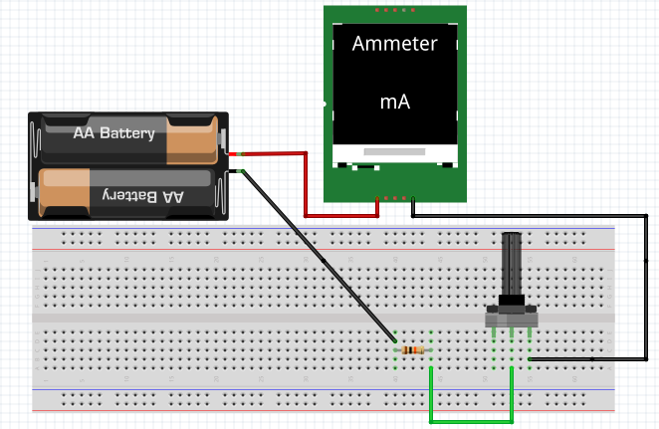

Resistors usually are marked with a color code, where each band of color has a meaning.

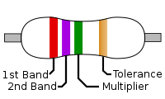

General meaning of bands. Higher precision resistors can have another band.

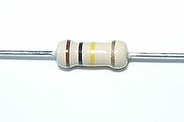

Example: A 100K 5% tolerance resistor

In real life, it is often hard to tell the colors of the resistor bands and a multimeter is used to verify the resistance value.

#### Exercise 3:

Grab two resistors at random from the box. Put in parallel on a breadboard. Calculate and measure the resistance. Calculate and then measure the current flowing through the parallel resistors.

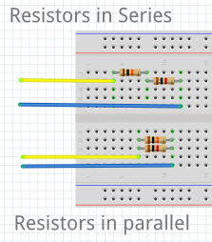

#### Exercise 4:

Put two capacitors in series. Calculate the capacitance. Then measure.

Sometimes capacitance is written on the capacitor, other times it is written with tiny numbers which require a magnifying glass to read.

Microfarad $μF$ = ${10}^{-6}$

Nanofarad nF = $10{}^{-9}$

Picofarad pF = $10{}^{-12}$

Then put two capacitors in parallel. Then measure the capacitance. This requires a multimeter which measures capacitance. Notice the printed band indicating the negative lead of the electrolytic capacitor (pictured below, right).

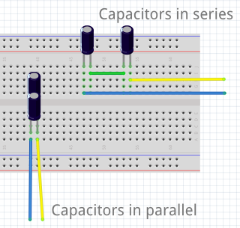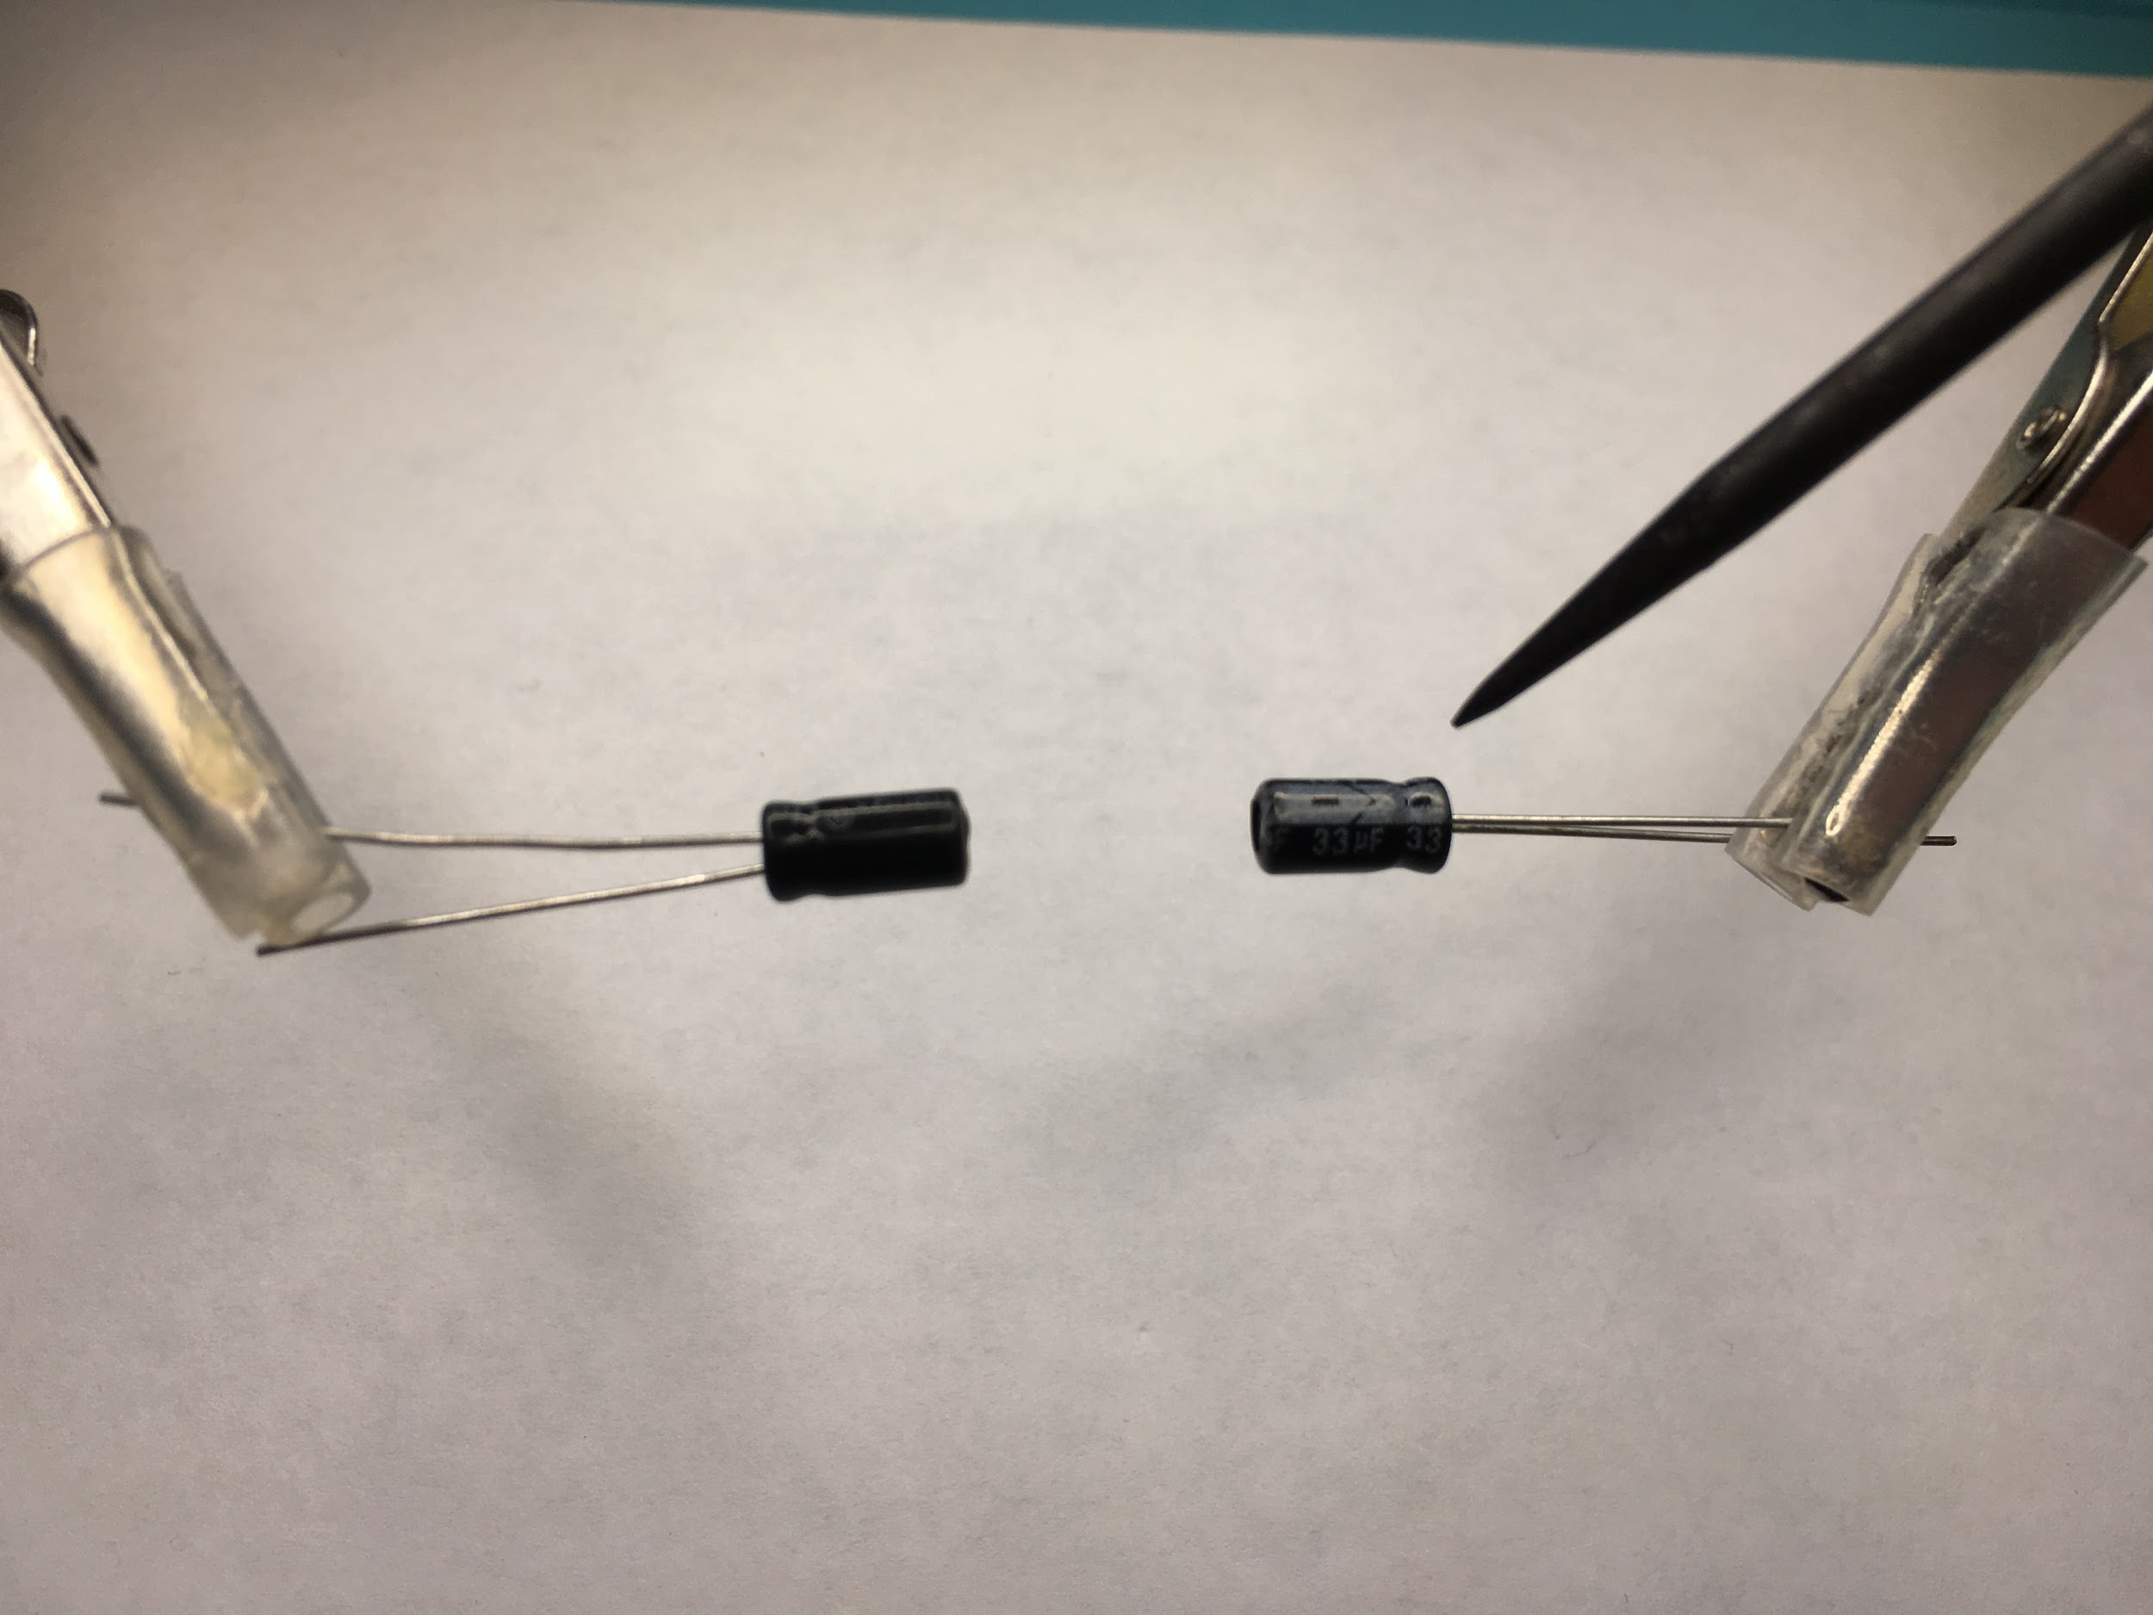

#### Exercise 5:

Put two inductors in parallel. Calculate then measure the inductance.

Put two inductors in series. Measure the inductance.

